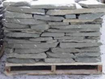
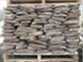
Force’s Stone & Landscape Supply

Our Stone Products
Wallstone – Comes in Gray Fieldstone, Off Color (Gray/Green) colonial, Blue Colonial, Creekstone, Lilac(red) Colonial, Red Fieldstone.
- All Wallstone products are stacked 28”-30” Tall on a 3’x4’ Pallet.
- Each Pallet Weighs Between 2800-3200 lbs. and are approximately 28-30 Cubic Ft.
- All Wallstone come in thicknesses of 1”-4” and 4”-8”.
Purposes- Retaining walls, Boundary walls, House Facing, Fireplaces, Garden Borders, Etc.
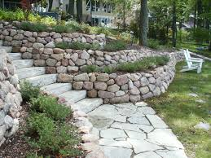
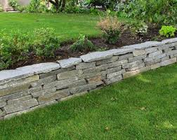
Retaining Walls

Boundary Wall
Fire Place
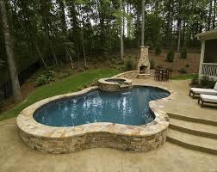
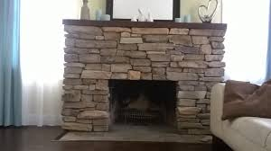

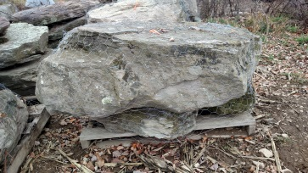
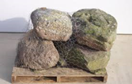
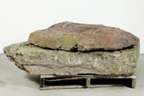
Boulders- Boulders come in multiple different shapes and sizes.
- Most boulders are fieldstone grey/red.
- Boulder Pallets range from 1 Per Pallet up to 6-7 per pallet.
- Boulders are great for retaining walls, lawn edges, and accent rocks. Also excellent for using with mulch, edges of waterfalls, pool borders and much more!
Garden Accents
Retaining Wall

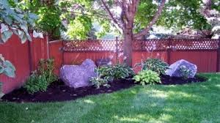
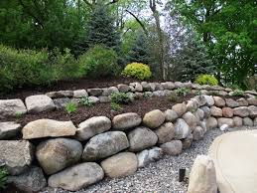

Pool Edging

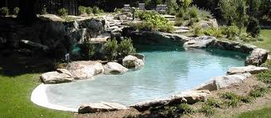

Slabs/ Steps – Slabs come in multiple sizes from 2 ft by 3ft to 6ft by 5ft and anywhere in between and sometimes larger!
- Slabs come in two different thicknesses 3”-5” and 5”-8”.
- The 3”-5” are primarily used for waterfalls, dry layed pathways/driveways , natural stone steps, benches, and many other creative things.
- The 5”-8” are predominately used for retaining walls and natural stone steps, or sidewalks they can also be used for waterfalls and garden borders.
- Slabs come in multiple sizes and shapes therefor it is usually quite difficult to determine the actual square footage. I sell them by the pallet to you but you may want to sell them by the rock or the pallet whichever you find works better for your customers. A general rule of thumb is that when you order a pallet of 3”-5” slabs you should expect 4-6 rocks on that pallet with dimensions roughly 3’x4’ slightly larger or slightly smaller, if the rocks are 5’-6’ long there may only be 3-4 on a pallet depending on the thickness of the stone and the weight of the overall pallet. The 5”-8” slabs you should expect to see 3-5 rocks per pallet depending on size, weight, and thickness.
Natural Fieldstone Steps
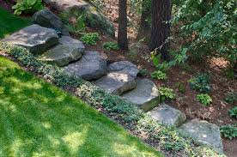
Slabs come in both Colonial and Fieldstone.
Natural Steps
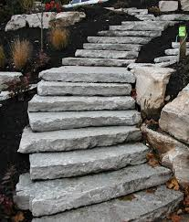

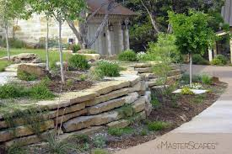
Natural Step
Retaining Wall

Garden Paths/ Steppers- Garden Paths come on a Standard 3’x4’ Pallet. Each rock is a minimum of 12”x 24” and can be any size between and up to 2’x3’.
- All sizes are rough edged and not generally square they are a natural edged stone. Each pallet generally has between 25-40 rocks on each pallet and weighs between 2600lbs- 3000lbs.
- Each pallet will cover approximately 75 sq. ft..
Garden Paths are mainly used for walkways in a flower bed, wall caps, retaining walls, and pond edging. But there are several other uses for this product you just have to have a creative mind and a good mason!
Colonial Side By Side
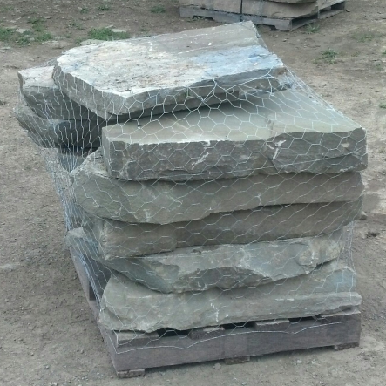
Colonial Garden Path
Fieldstone Garden Path
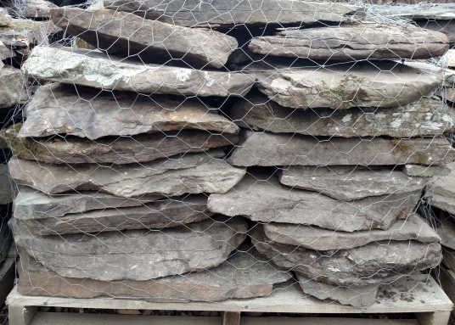

Natural Garden Walkways

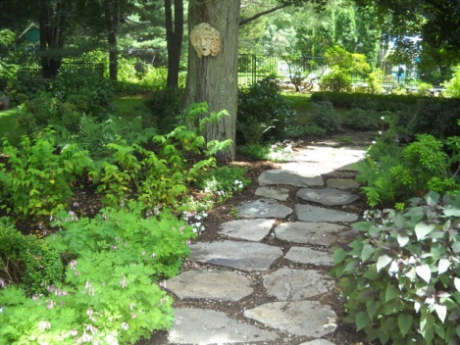
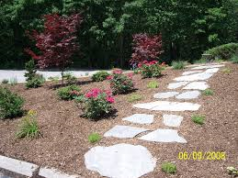

Half Pallets & Toners-
- Half Pallets are stacked 18”-20” tall on a 3’x3’ pallet and weigh approximately 1500lbs.
- Each pallet has 14-15 cubic ft. of stone. Half Pallets come in gray/red Fieldstone, Colonial, Lilac, and Creekstone.
- Toners are stacked 20” tall on a standard 3’x4’ pallet and weigh approximately 2000lbs. “Hence the name toner.”
- Toners also come in gray/red Fieldstone, Colonial, Lilac, and Creekstone.
Fieldstone Half Pallets
Colonial Half Pallets
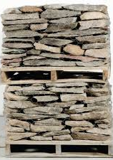

Creekstone

Stand Up Irregular- Stand up comes in 4 different size ranges 1/2”, 1”, 1.5”, and 2”.
- Stand up pallets are sold both by the weight or the pallet depending on the job application where it is required.
- Stand up is large sheets from 2.5’-7’ tall, the width of each piece varies anywhere from 8” wide to 36” wide and should have at least one flat smooth face on each rock.
- Stand up pallets generally weigh between 3200lbs-4000lbs and will cover a wide span of square footages depending on size of the sheets.
- If customer includes sq. ft. needed for the job I can measure the necessary pallets and ship you the product you need.
- Stand up comes in gray, blue, and lilac.
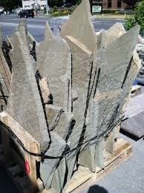
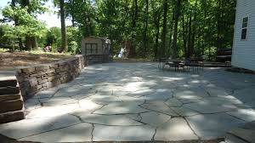
- Stand up is generally used for pool edging, pond coping, dry laid patios, wet laid patios (with concrete) and many other applications.
1.5” Stand Up Pallet
Dry Layed Patio

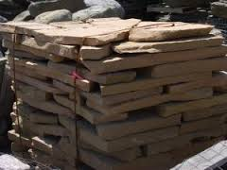
Natural Flagging- Natural Flagging is similar to the garden paths but the thicknesses are less.
- Basically flagging is smaller pieces of stand up irregular laid on a 3’x4’ pallet.
- Pieces are smaller and for some jobs are of greater use than the larger stand up sheets.
- Natural flagging can be a cheaper solution than the standup irregular, giving the amount of stone required to build your project.
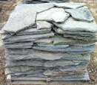
- Flagging comes on pallets with thicknesses between 1” & 2”.
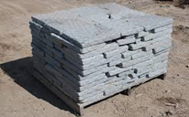
Tumbled Bluestone- Tumbled stone comes in half pallets
and full pallets, Along with garden paths (Special Order).
- Tumble comes in thicknesses of 1”, 1.5”,& 2”.
- Tumbled stone is used for retaining walls, pond coping, dry laid patios and much more!
- Tumble can be ordered in natural edged pieces or dimensionally cut and then tumbled.
- The dimensionally cut tumble come in sizes of 6”x6” or 1’x1’. Other sizes must be custom ordered.
Tumbled Retaining Wall

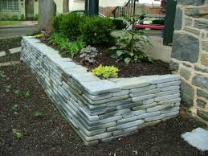

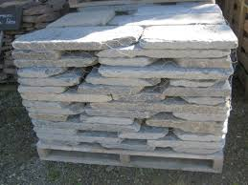
Tumbled Garden Path

Natural Flagstone- Natural Flagstone is sold by the square ft. there are multiple sizes of natural flagstone such as-
1’x1’ 1’x18” 1’x2’ 1’x30” 1’x3’
18”x18” 18”x2’ 18”x30” 18”x3’ 2’x2’
2’x30” 2’x3’ 3’x3’
We can also custom cut Special Sizes if product is available to be cut.
Natural Flagstone should have at least one natural smooth face.
Natural Flagstone comes in thicknesses of ½”,1”,1.5”,2”. We can also get 3” Sidewalk steps, which are usually 2’x2’.
Flagstone can be used for anything from Patios, sidewalks, steps, wall caps, and many more.
We also sell Flagstone pallets with mixed dimensions for jobs that need to have different sizes. For example if you need to offset seams laying a dry laid patio you may want to use 1x1’s, 1x18’s, and 1x2’s all mixed and matched together. So we do offer mixed pallets with a description of how many pieces and Sq ft. of each dimension on each pallet.
Natural Flagstone Patio
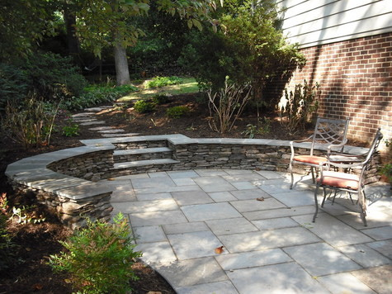
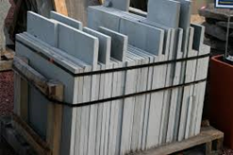

Thermal Flagstone- Thermal Flagstone comes in the same size dimensions as the Natural Flagstone, and also the same thicknesses. The largest difference between Natural Flagstone and Thermal Flagstone is that the thermal flagstone is burnt with a torch and custom cut with large saws to make every piece perfectly flat on both sides and allows it to have two faces instead of maybe only having one good face.
Along with the thermal being “artificially cut” it is also more expensive than natural flagstone because there is more work involved in making it a smoother more workable material. Many masons and landscapers like using thermal because it is easier and faster to lay and complete jobs. But if you prefer the natural look or would like to keep the natural stone face on your wall caps then natural stone is the better choice for you. They are both great products they just depend on project budget and your personal preference.
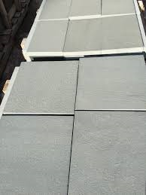
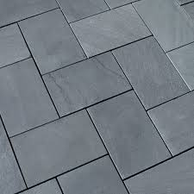

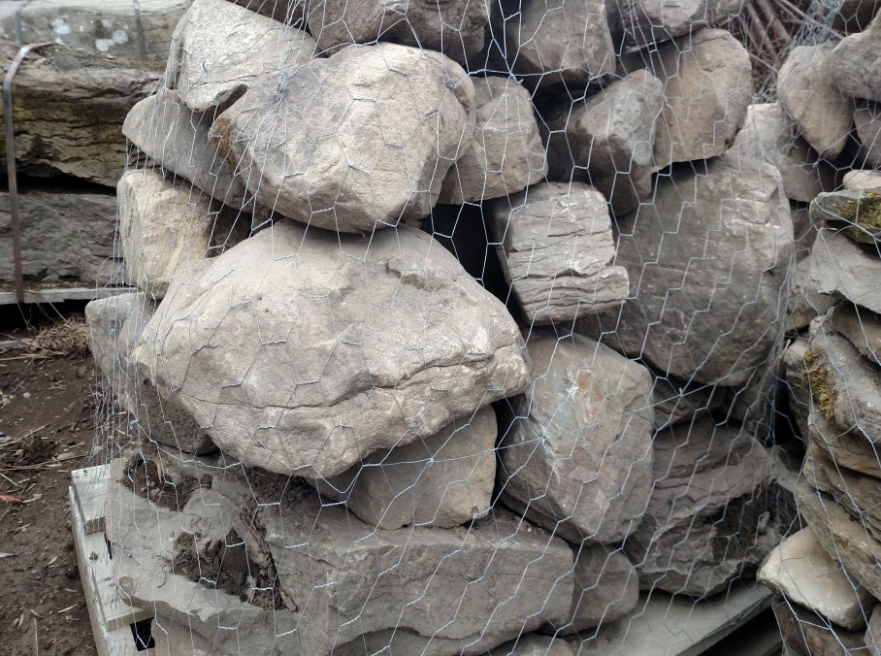
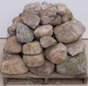
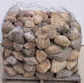
Garden Boulders- Garden boulders come in various sizes
and shapes.
- Garden boulders will either come on a wired pallet
or a basket pallet.
- Garden boulders are mainly used for garden
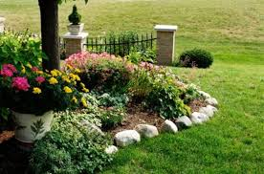
perimeters and retaining walls.
Garden Boundary

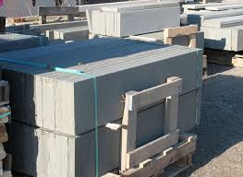
Thermal Treads- Treads Come in various sizes and widths. They start at 3 feet long and can go up to 8-10 feet long, and from depths of 12” wide to 24” wide.
Treads are cut from Pennsylvania Bluestone Quarries using large saws and generally require to be pre ordered because they are a very hot item in the stone world. Treads are usually 2” thick and are 100% bluestone.
Pallets can get extremely heavy so certain sizes require larger equipment than a skid steer to load and unload.
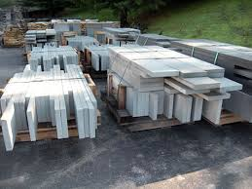
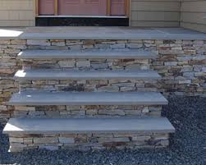
Treads are used for making Steps, Sidewalks, Benches and many other great things.

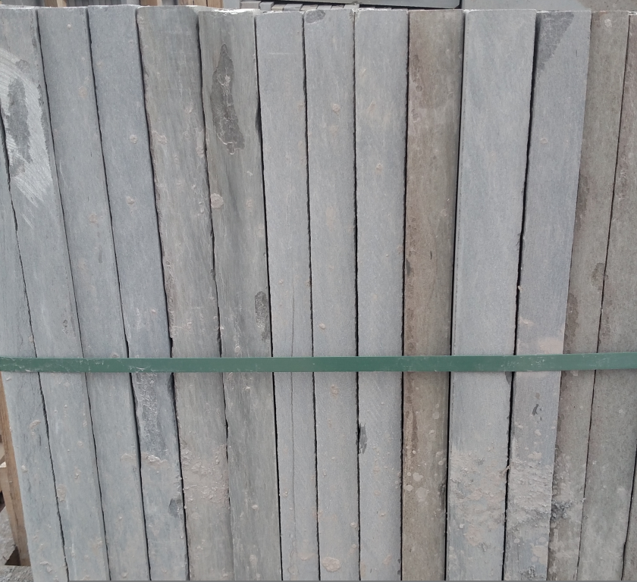
Thermal Blackjack Pattern- Blackjack Pattern Comes in the same sizes as the regular thermal pattern and also comes in 1”, 1.5”, and 2” thicknesses. The difference between the blackjack and the normal pattern is that the blackjack has specks and blotches of black in the faces and edges of the rock. It actually adds a lot of character to the rock and makes every piece unique. It is also slightly cheaper than the off color pattern and it makes a beautiful patio or pool edging area because of the defaults in each piece being different.

